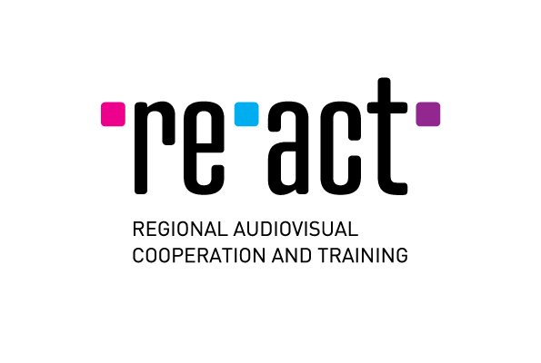
TFL/RE-ACT Workshop
September 17 - 19, 2019

APPLICATION FORM
Deadline: 4 July 2019

Please complete this form and send it together with other requested documents to: info@filmreact.eu

Date
Producer (first & last name)
Nationality
Production company
Position in the company
Address
City
Country
E-mail (will be used for all communication)
Phone number
Title of the project in English
Original title of the project
Name of the director
Name of the scriptwriter
Estimated duration of the project (in minutes)

Application documents to be sent in English (each document as a separate word/pdf document):

Use boxes below as a checklist to mark the document (X) you are attaching):

FICTION | This application form, completed (as a word document)
FICTION | 1 page letter of motivation (why are you applying for this workshop?)
FICTION | 1 page synopsis
FICTION | Treatment/dossier (max 8 pages)
FICTION | Teaser/visual materials (not mandatory)
FICTION | Note of intention of the producer and director
FICTION | Profiles of the producer and director
FICTION | Company profile

